
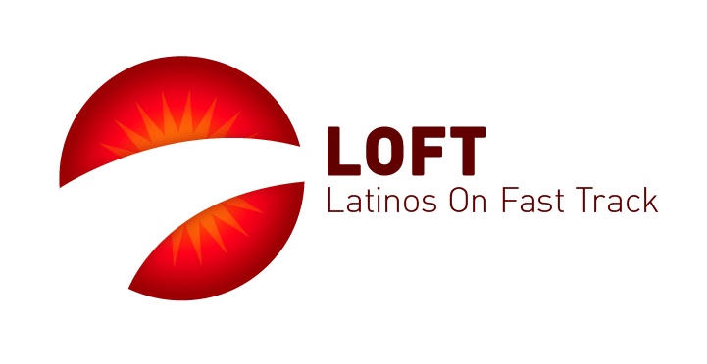

LOFT Fellowship
Fellowship Program for Science and Engineering Students
ExxonMobil LOFT Fellowship

ExxonMobil LOFT Fellowship
ExxonMobil, one of the world’s largest publically traded international oil and gas companies, has collaborated with the Hispanic Heritage Foundation (HHF) to create fellowships in STEM fields (Science, Technology, Engineering and Math) for Hispanic college students. Through HHF’s Latinos On Fast Track (LOFT) program, ExxonMobil seeks to nurture and motivate college students across the country, with a passion for Engineering and Science.

Students selected will be exposed to a top quality company by participating in this signature-mentoring program. Each student will be paired up with one of ExxonMobil engineers/scientists to learn how their knowledge is applied in a corporate setting.

Fellowship Components
The Fellowship consists of five 1-hour meetings with mentor (virtual or in person), participation in the Harvard-certified ExxonMobil mentee program (on-line), an exclusive curriculum to introduce Fellows to the organization and company career opportunities, and a $1,000 educational grant. In addition, there exists the possibility to interview for ExxonMobil positions (internships/full-time) upon successful completion of the Fellowship.

Fellowship Requirements
This opportunity is highly competitive and open to college sophomores, juniors, seniors and graduate students attending a 4-year college or university.

- Fellowship applicants with the following majors will be given priority:
• Chemical Engineering
• Civil Engineering
• Electrical Engineering
• Mechanical Engineering

- Applicants with these majors will be considered also:
Computer Engineering, Chemistry, Environmental Engineering, Geology, Industrial Engineering, Material Sciences, Mathematics, Materials Engineering, Petroleum Engineering, and Physics

- Other Requirements:
• Must plan to pursue a career in the fields/majors listed above
• Have a GPA of 3.5 or higher
• Be a U.S. citizen or legal permanent resident of the United States with a valid Social Security Number at the time of application. All legal permanent residents must submit a copy of their valid permanent resident card or passport stamped I-551 (not expired).

All interested candidates apply here and send resume to Julian@hispanicheritage.org. Please use "ExxonMobil LOFT Fellowship" in subject line.

